Experiment 22: Sharpening using Laplacian Mask with Positive Center Coefficient
Software / Tools: Python · OpenCV (cv2) · NumPy

AIM
To sharpen an image using a Laplacian mask with a positive center coefficient, where the addition of the original image is already built into the mask.
ALGORITHM
1. Import OpenCV and NumPy.
2. Read the input image.
3. Define the composite kernel [[0,-1,0],[-1,5,-1],[0,-1,0]] — this already represents g(x,y) = f(x,y) + Laplacian, since the center coefficient (5) is positive.
4. Apply cv2.filter2D() directly with this kernel (no separate subtraction/addition needed).
5. Display and save the sharpened image.
PROGRAM (SOURCE CODE)
import cv2
import numpy as np

img = cv2.imread("image.jpg")

# Positive-center Laplacian mask (addition already built in)
kernel = np.array([[0, -1, 0],
[-1, 5, -1],
[0, -1, 0]])

sharpened = cv2.filter2D(img, -1, kernel)

cv2.imshow("Sharpened (Positive Center)", sharpened)
cv2.waitKey(0)
cv2.destroyAllWindows()

OUTPUT
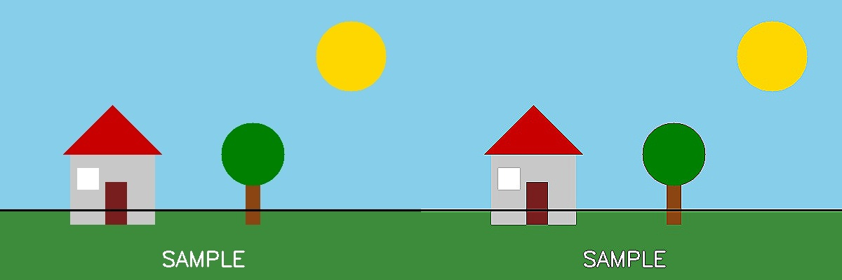
Fig. 22 — Output of Experiment 22: Sharpening using Laplacian Mask with Positive Center Coefficient.
RESULT
Sharpen an image using a Laplacian mask with a positive center coefficient, where the addition of the original image is already built into the mask — completed successfully, as demonstrated in the output shown above.

